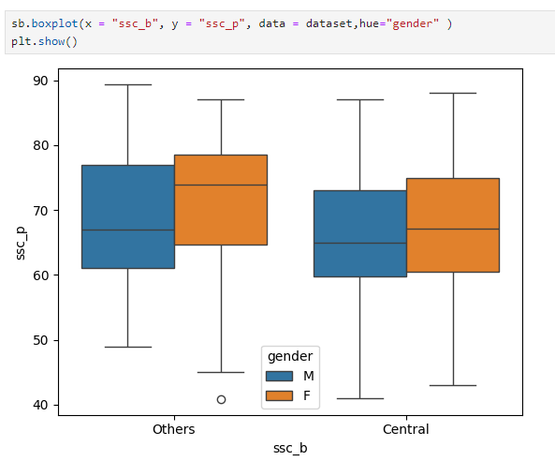

**Interpretation:**

1. **Syllabus Categories (ssc_b)**:
   * The x-axis shows two categories: "Others" and "Central," representing different types of syllabuses.
2. **Score Distribution (ssc_p)**:
   * The y-axis represents the scores obtained by students in their 10th grade (ssc_p).
3. **Gender Breakdown**:
   * The plot is divided by gender using the hue="gender" argument. The blue box represents males (M), and the orange box represents females (F).

**Key Observations:**

1. **"Others" Syllabus**:
   * Both males and females have a wide range of scores, with scores typically ranging from around 55 to 80.
   * The median score (the line within the box) is slightly higher for females than males, suggesting that on average, females might have performed slightly better.
   * The interquartile range (IQR), represented by the box, is wider for males, indicating greater variability in male scores.
2. **"Central" Syllabus**:
   * Again, both genders show a wide range of scores, with scores ranging from about 55 to 75.
   * The median score is nearly identical for both genders in the "Central" syllabus.
   * The IQR is similar for both genders, with females showing a slightly lower median but with similar variability compared to males.
3. **Overall Trend**:
   * Students from both genders and syllabuses seem to have a similar distribution of scores, but there might be slight differences in performance, with females in the "Others" syllabus showing a slightly higher median.
   * The presence of an outlier (a circle below the lower whisker in the "Others" syllabus for males) indicates that at least one male student scored significantly lower than the rest.